Jake Traut

CSCI 4446 Problem Set 13

Three Body System

1. 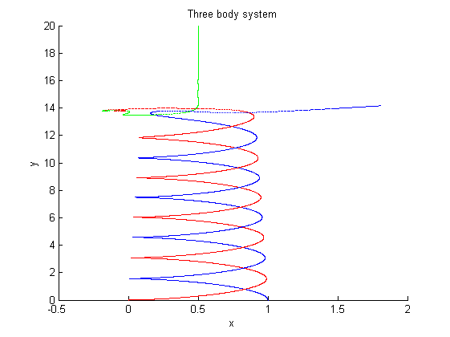 With the 3rd star introduced, starting at 3000 units away from the binary stars with zero velocity, it just stayed stationary while the binary stars proceed to stay in their orbit but progressively getting more spread in distance between stars (along y) and becoming narrower loops (not maintaining orbit of [0, 1] on x axis).
2. 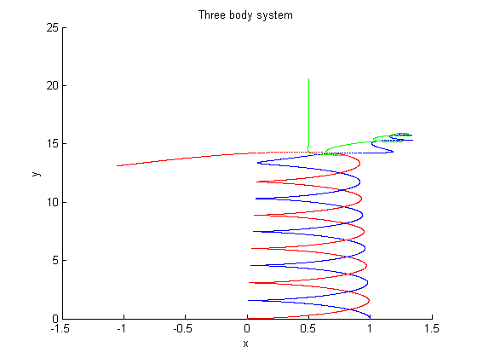Plots

The first plot captures some of the resulting behavior seen in Hut & Bahcall’s picture where the 2nd star (blue) launches off in its own trajectory in the positive x direction, while stars 1 (red) and 3 (green) end up in their own binary system heading in the negative x direction. The second plot shown, where I started the 3rd start at 20.6 away from the binary rather than 20, the resulting binary of the three bodies is the 3rd start with the 2nd star in the opposite direction. Neither of these plots shows the elaborate chaotic orbits that occur when the 3 bodies “hit” before entering their respective outcome trajectories. Our frame of reference is also looking from the origin star (1, red), whereas Hut & Bahcall does not start with a frame of reference focused on a single star but rather a more overview angle looking along the x.

1. 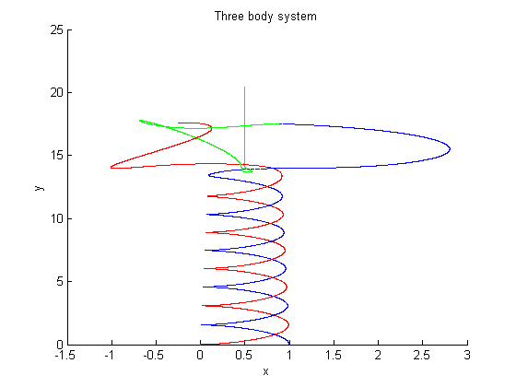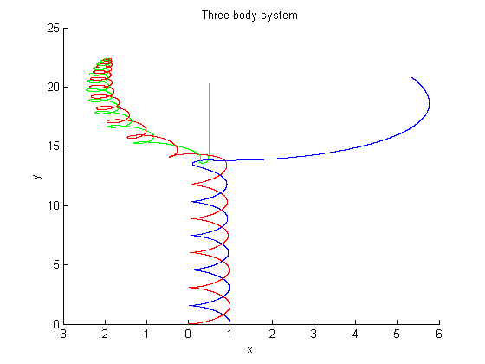More interesting plots from tweaking A-RK4 error tolerance & 3rd body initial distance away.